  Serving up global delicacies  3-night complimentary hotel stays for NEW buyers | Limited Quota  First-come-first-served  - Excellent Portfolio of Food Suppliers: Expecting over 1,500 exhibitors from more than 25 countries and regions  - Efficient Sourcing Platform: Customized one-to-one business matching sessions  - Major Exhibits includes Bakery Products, Fruit & Vegetables, Health, Green & Organic Food,  Snacks & Confectionery, Meat & Poultry, Canned, Frozen & Processed Food, Seafood, etc.  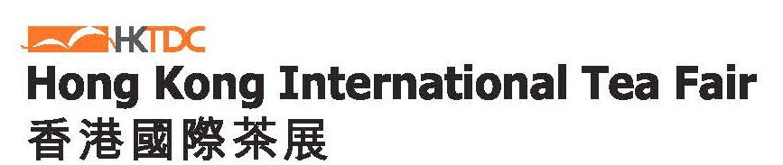  - Concurrent fair:  *Trade Only from 11-13 August  Contact Us Mr. Cyril Fok at Tel: (852) 2240 4203 / Fax: (852) 2169 9169 / Email: hkfoodexpo.visitor@hktdc.org  HKTDC Food Expo 2018 - Reply Slip for Hotel Sponsorship  Please return this Reply Slip by fax to (852) 2169 9169 or by email hkfoodexpo.visitor@hktdc.org before 20 July 2018 (Friday).  To complete your application, please get the following ready for faxing: 1. Completed Reply Slip 2. Business Card  **Hotel Sponsorship acknowledgement letter will be issued once your application is approved and this reply slilp is NOT for hotel check-in**
  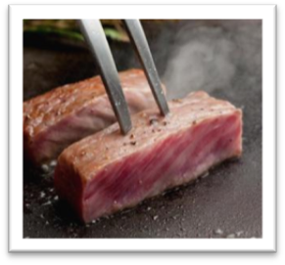3-night complimentary hotel stay for Overseas New Buyers · First-come-first-served
  - HKTDC will fully sponsor you 3-night hotel accommodation in Hong Kong at our pre-selected hotel during the nights of 15-17 August 2018 (inclusive) if you are an eligible buyer to join the programme.
  - To redeem the 3-night hotel voucher, the buyer has to follow a programme which includes but not limited to visiting the fair on both 16 and 17 August, and completing a buyer questionnaire.
Choice of Hotels  (Select One Hotel Below) |  | Location | Rate/Night (HKD) | Room Type | Travelling Time (min)
 |  |  |  |  | Taxi | MTR
□ Metropark Hotel Mongkok # |  | 22 Lai Chi Kok Road, Kowloon, HK | 750 | Superior | 25 | 35
□ Rosedale Hotel Kowloon # |  | 86 Tai Kok Tsui Road Kowloon, HK | 720 | Superior | 25 | 35
□ Ibis Hong Kong North Point |  | 138 Java Road, North Point, HK | 560 | Standard | 15 | 25
* - MTR (Mass Transit Railway) refers to the subway system in HK.

Full Name Mr/Mrs/Ms (as shown in passport):
Company Name: Country:
Company Address: ________
Company Tel: Company Fax: Company Email:
Check-in Date: Check-out Date:
Credit Card No: ____ ______ Expiry Date: ____ Credit Card Type: □ VISA □ MC □ AE
Nature of Business __________________________ Interested Products:

***IMPORTANT NOTICE for INDIAN NATIONALS TRAVELLING to Hong Kong
The Immigration Department of the Government of the Hong Kong Special Administrative Region has announced that the Pre-arrival Registration for Indian Nationals has been implemented on 23 January 2017. The online service for “Pre-arrival Registration for Indian Nationals” is now opened. Please visit http://www.immd.gov.hk/eng/services/visas/pre-arrival_registration_for_indian_nationals.html for more details.

I accept the terms and conditions (please visit http://hkfoodexpo.hktdc.com/dm/2018/index.html) regarding this Hotel Sponsorship Programme and I understand that should there be disputes over the programme, the decision of the Organisers shall be final and binding. I also accept that the credit card information provided are solely for the purpose of applying for hotel accommodation for the aforementioned event handled by the respective hotel. The Organisers will purge the said credit card information after the event. Note: If you do not agree to provide the required credit card information in full, the Organisers will not be able to offer any hotel sponsorship programme. For enquiries, please contact HKTDC Head Office at (852) 1830668 or hktdc@hktdc.org I agree that the above information may be used by the Hong Kong Trade Development Council (HKTDC) for incorporation in all or any of its database for direct marketing and business matching, and for any other purposes as stated in the Privacy Policy Statement (available at www.hktdc.com/mis/pps/en). I confirm that I have the consent of each individual's name in this form to release their personal data for the purposes stated herein. □ Please tick here if you object to our use of your data for direct marketing.
Name ________________________________ Signature __________________________ Date _____________________
If you do not wish to receive any promotional and other materials from the Hong Kong Trade Development Council via fax, please contact us at tel [852-1830668] or complete the following information and return at fax [852-28034198] or [databank@hktdc.org]. 若閣下不欲繼續收取香港貿易發展局以傳真發送的任何宣傳及其他資料，請致電本局[852-1830668] ，或填寫下列資料並以傳真[852-28034198] / 電郵[databank@hktdc.org]交回。
傳真號碼 Fax No. ( ) ____________________ 公司 Co. name _____________________ 聯絡人 Contact Person _____________________

